First Screenshot showing previous Lab 7 content of Instructions and Data Parsed
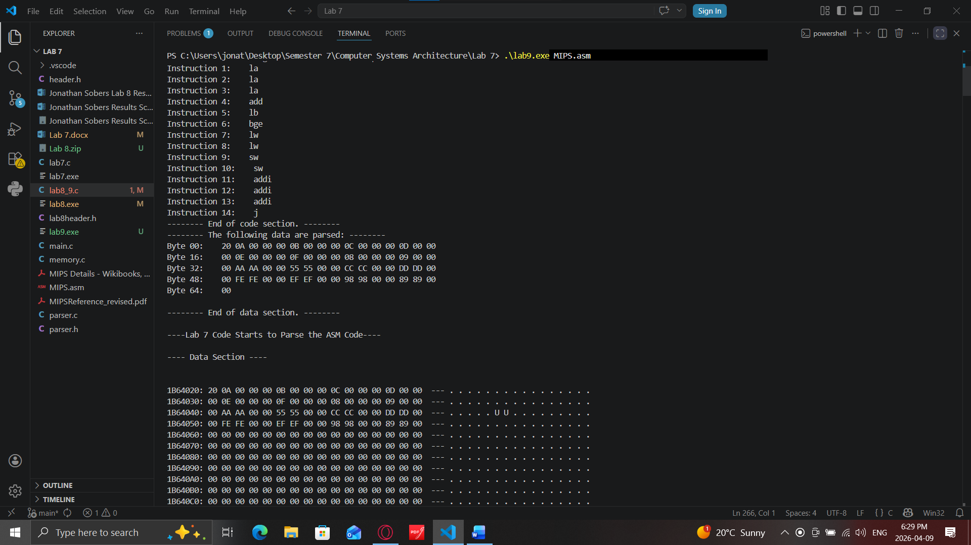
Second Screenshot showing the full Data Section and Code Section of the testdatas
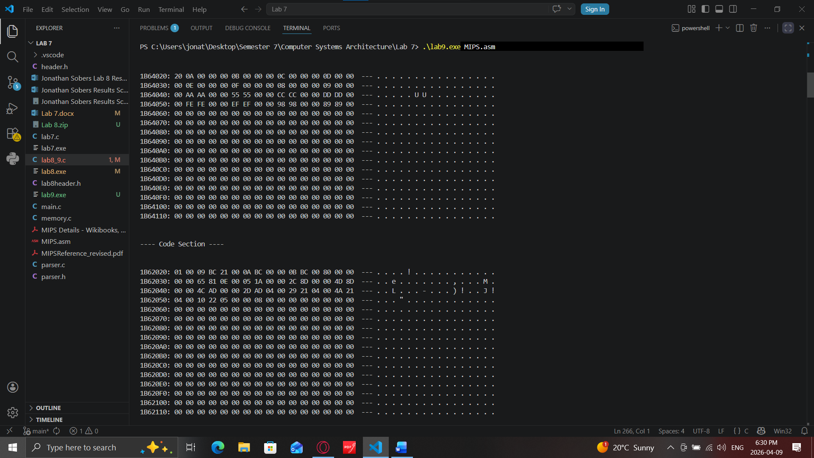
Third Screenshot showing the beginning of the Fetch and Decode section now being more populated since it ran 8 times
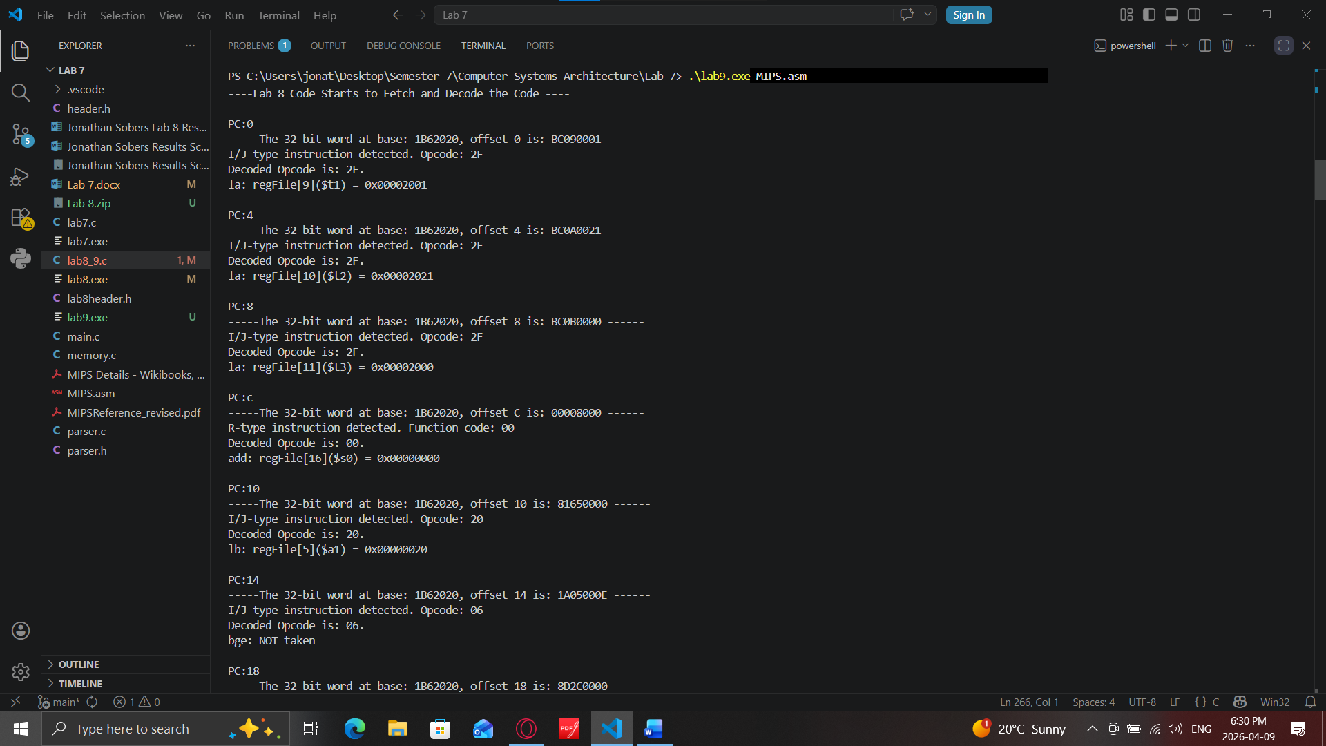
Fourth Screenshot showing continued Fetch and Decode
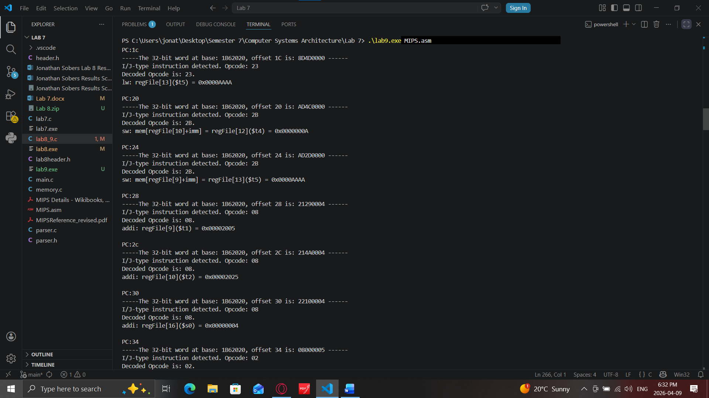
Fifth Screenshot showing continued Fetch and Decode this is new because of the stated 8 full iterations being ran.
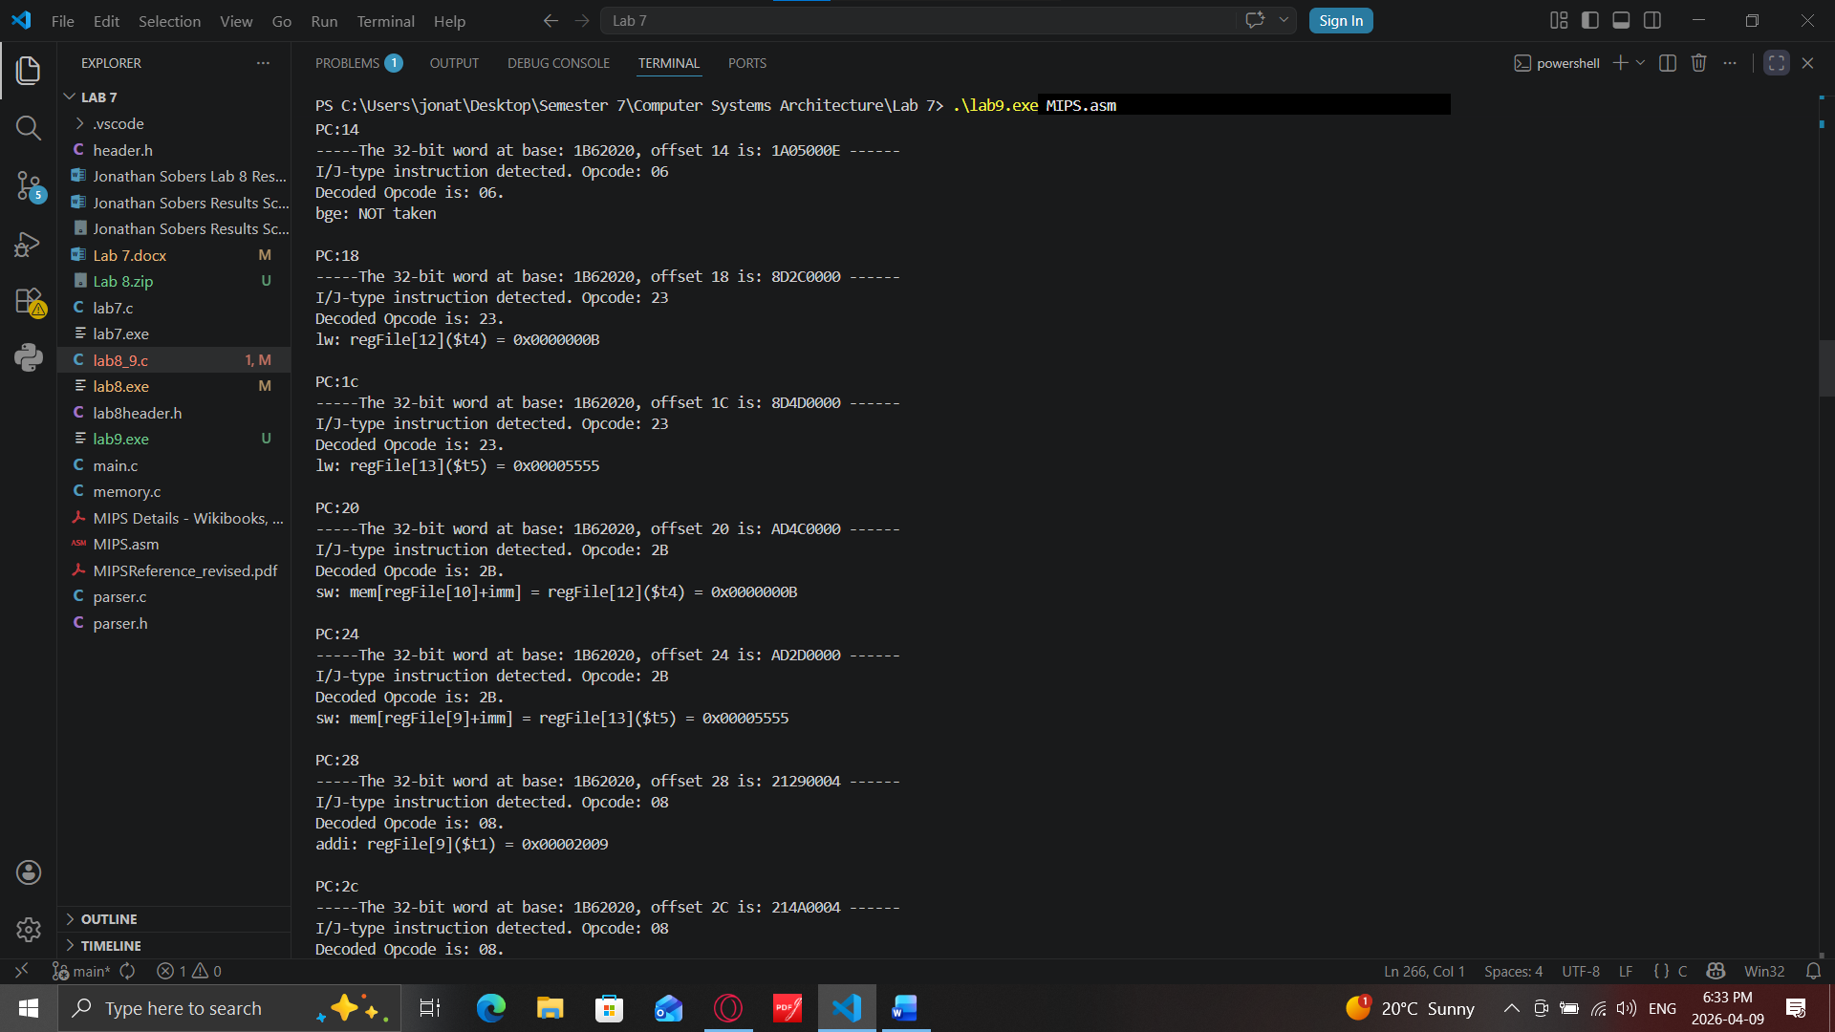
Sixth screenshot showing continued Fetch and Decode and another iteration being completed
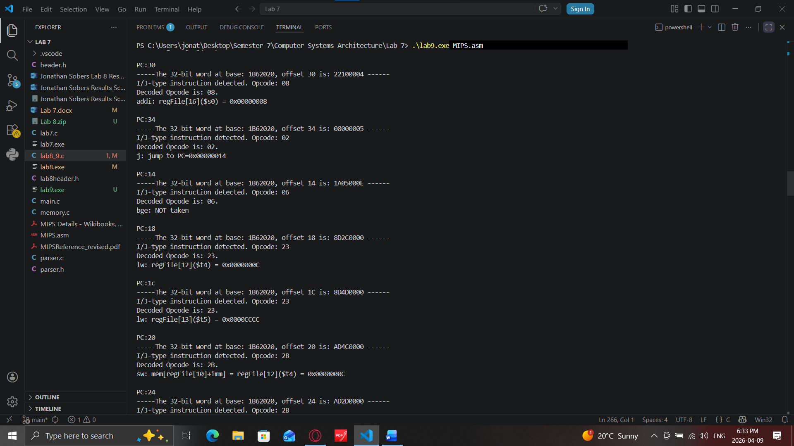
Seventh screenshot showing continued Fetch and Decode with the next Iteration beginning again
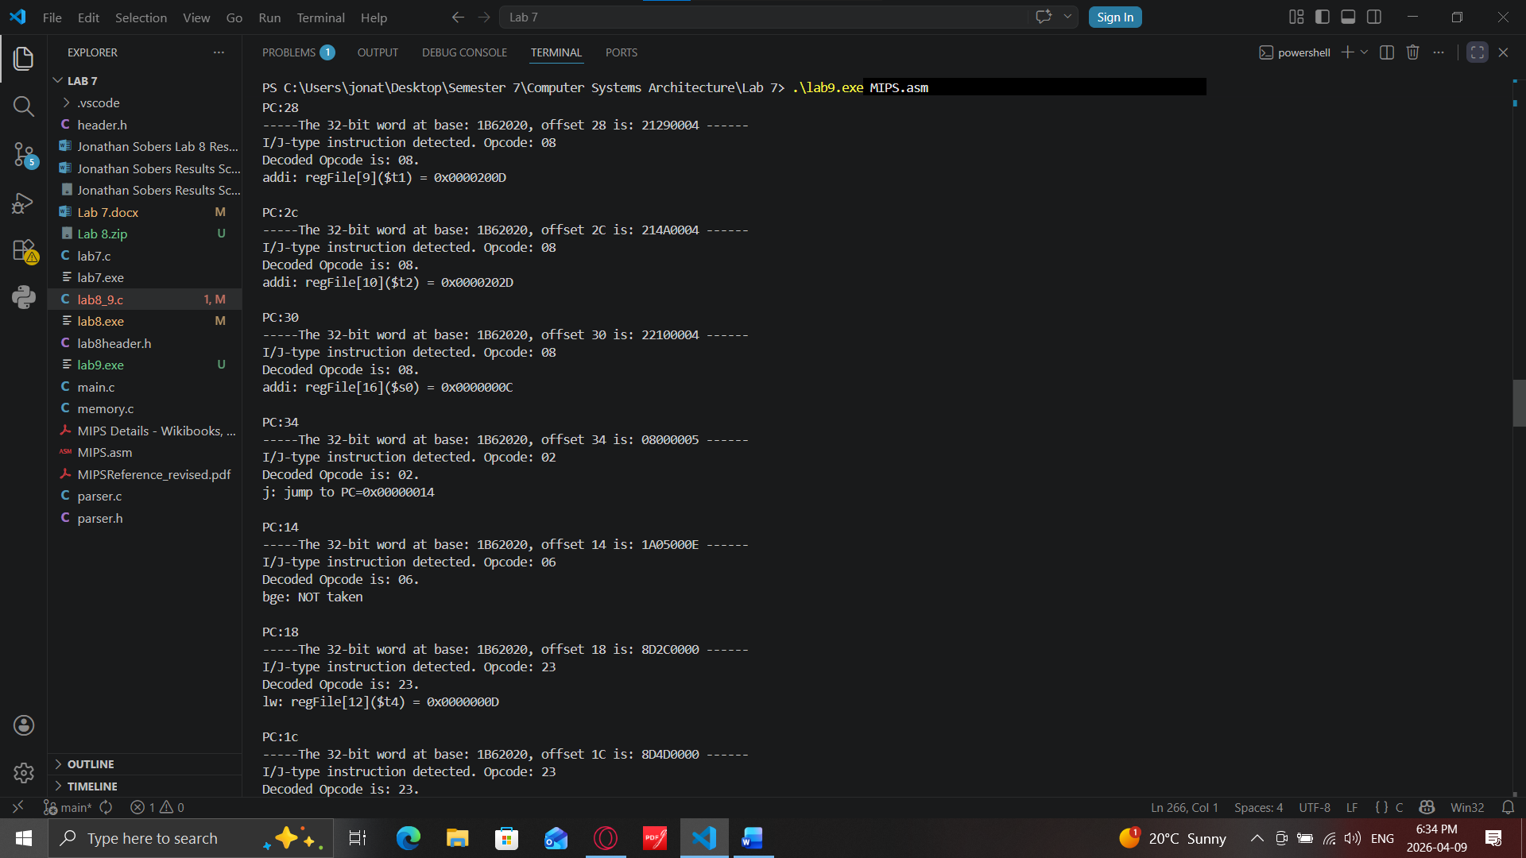
Eighth screenshot showing continued Fetch and Decode being made
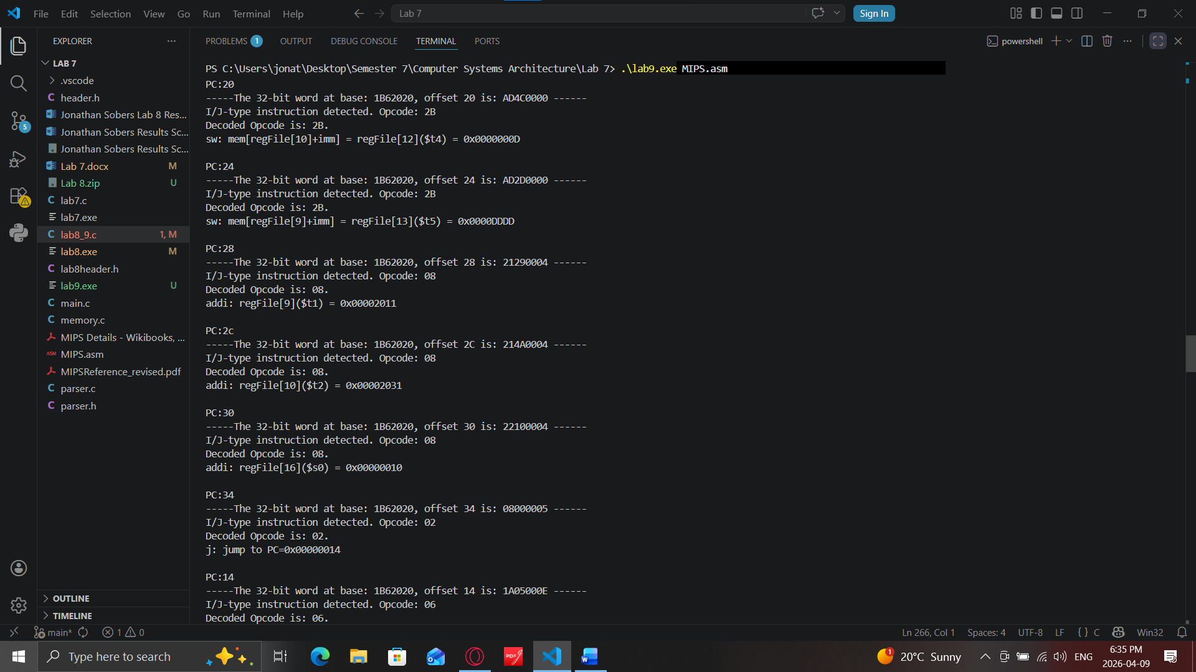
Ninth screenshot showing continued Fetch and Decode being implemented again
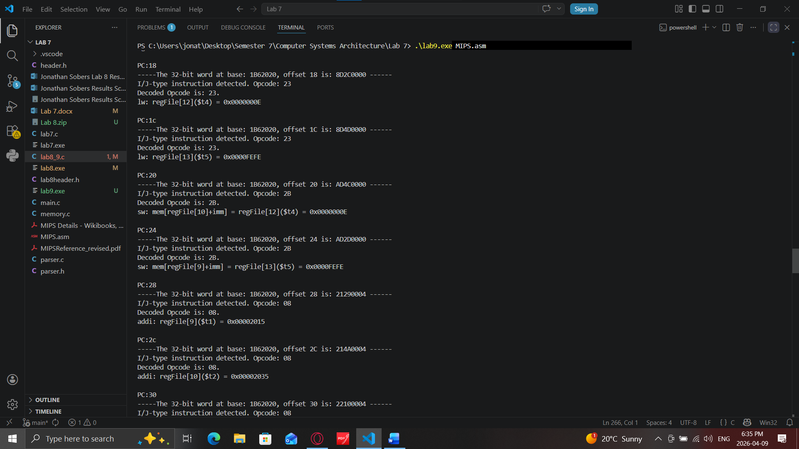
Tenth screenshot showing continued Fetch and Decode with almost all iterations being finished
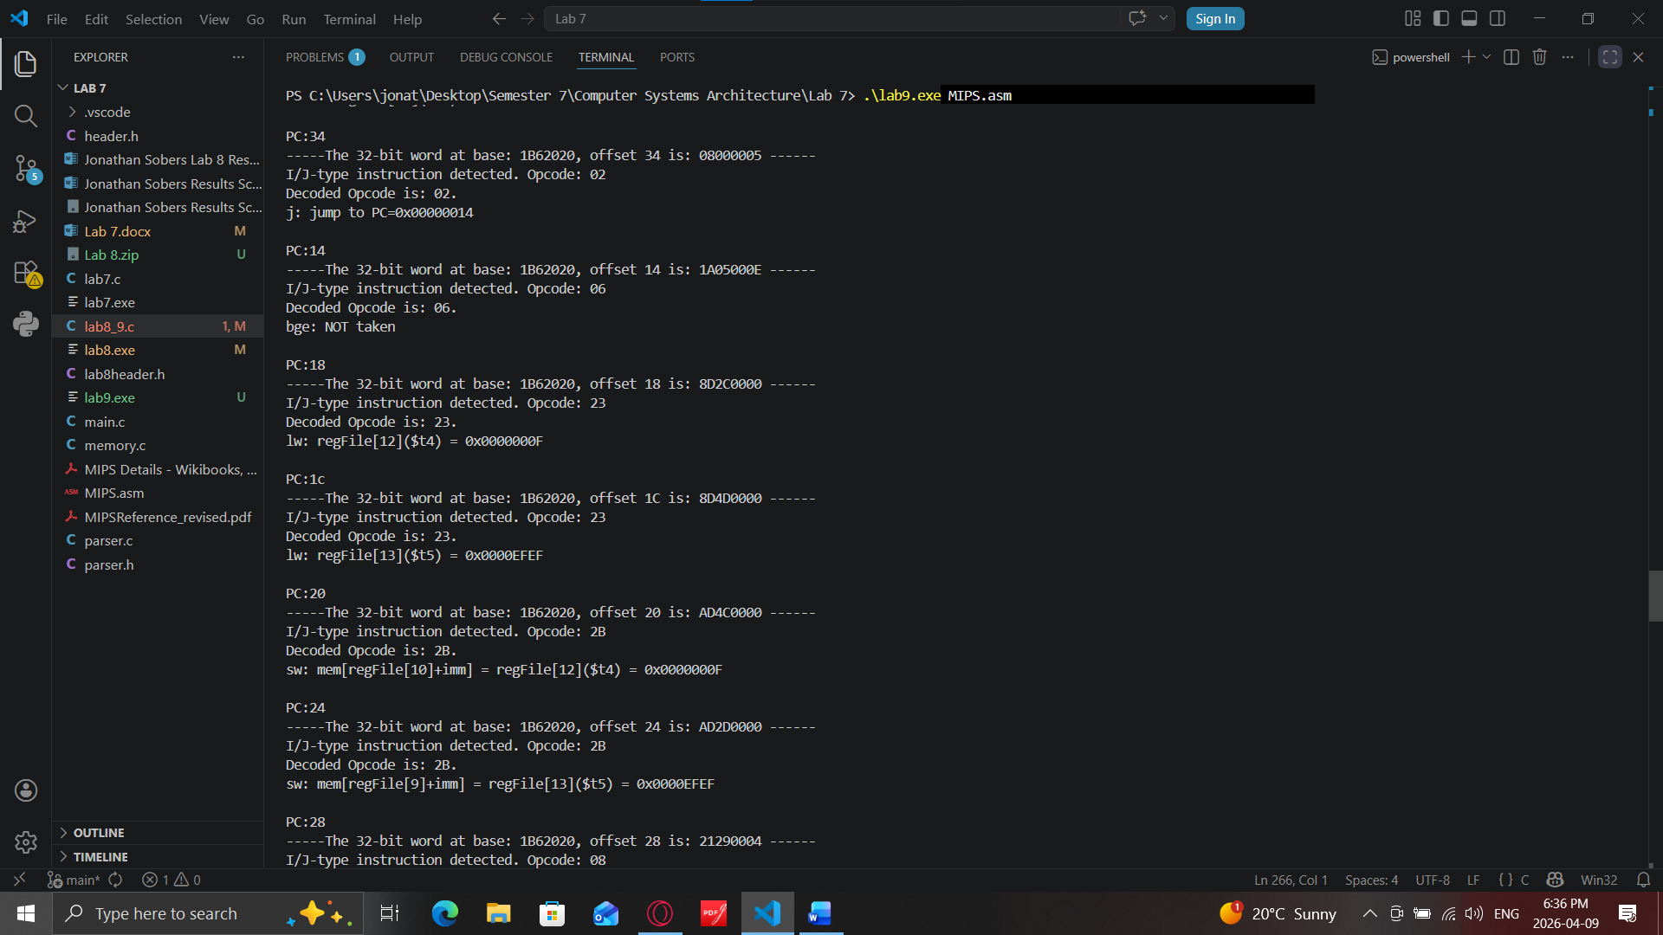
Eleventh screenshot showing continued Fetch and Decode
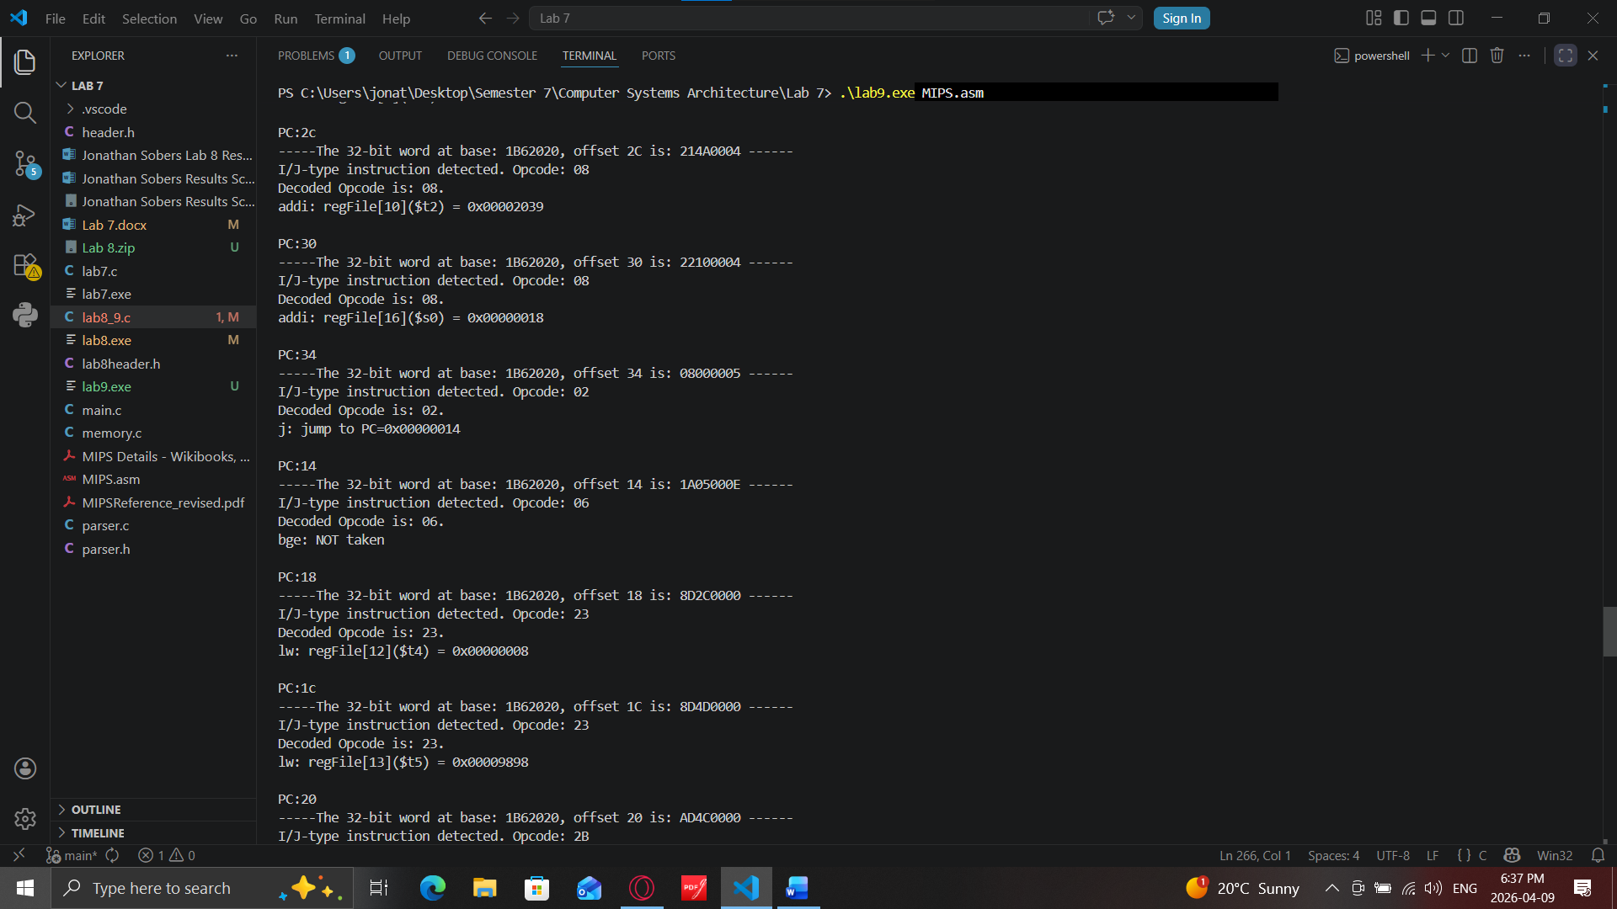
Twelve screenshot showing continued Fetch and Decode of the last iteration
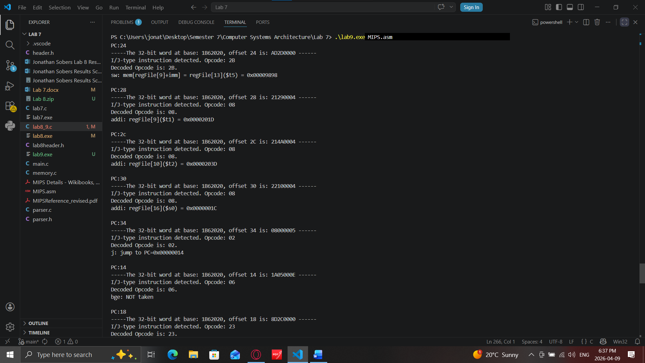
Thirteen screenshot showing last Fetch and Decode of the execution being completed
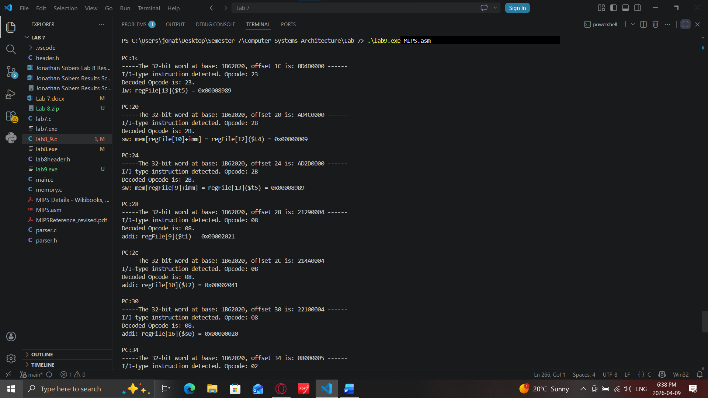
Fourteen screenshot showing Registered File Dump which is bigger now that the Execution went through
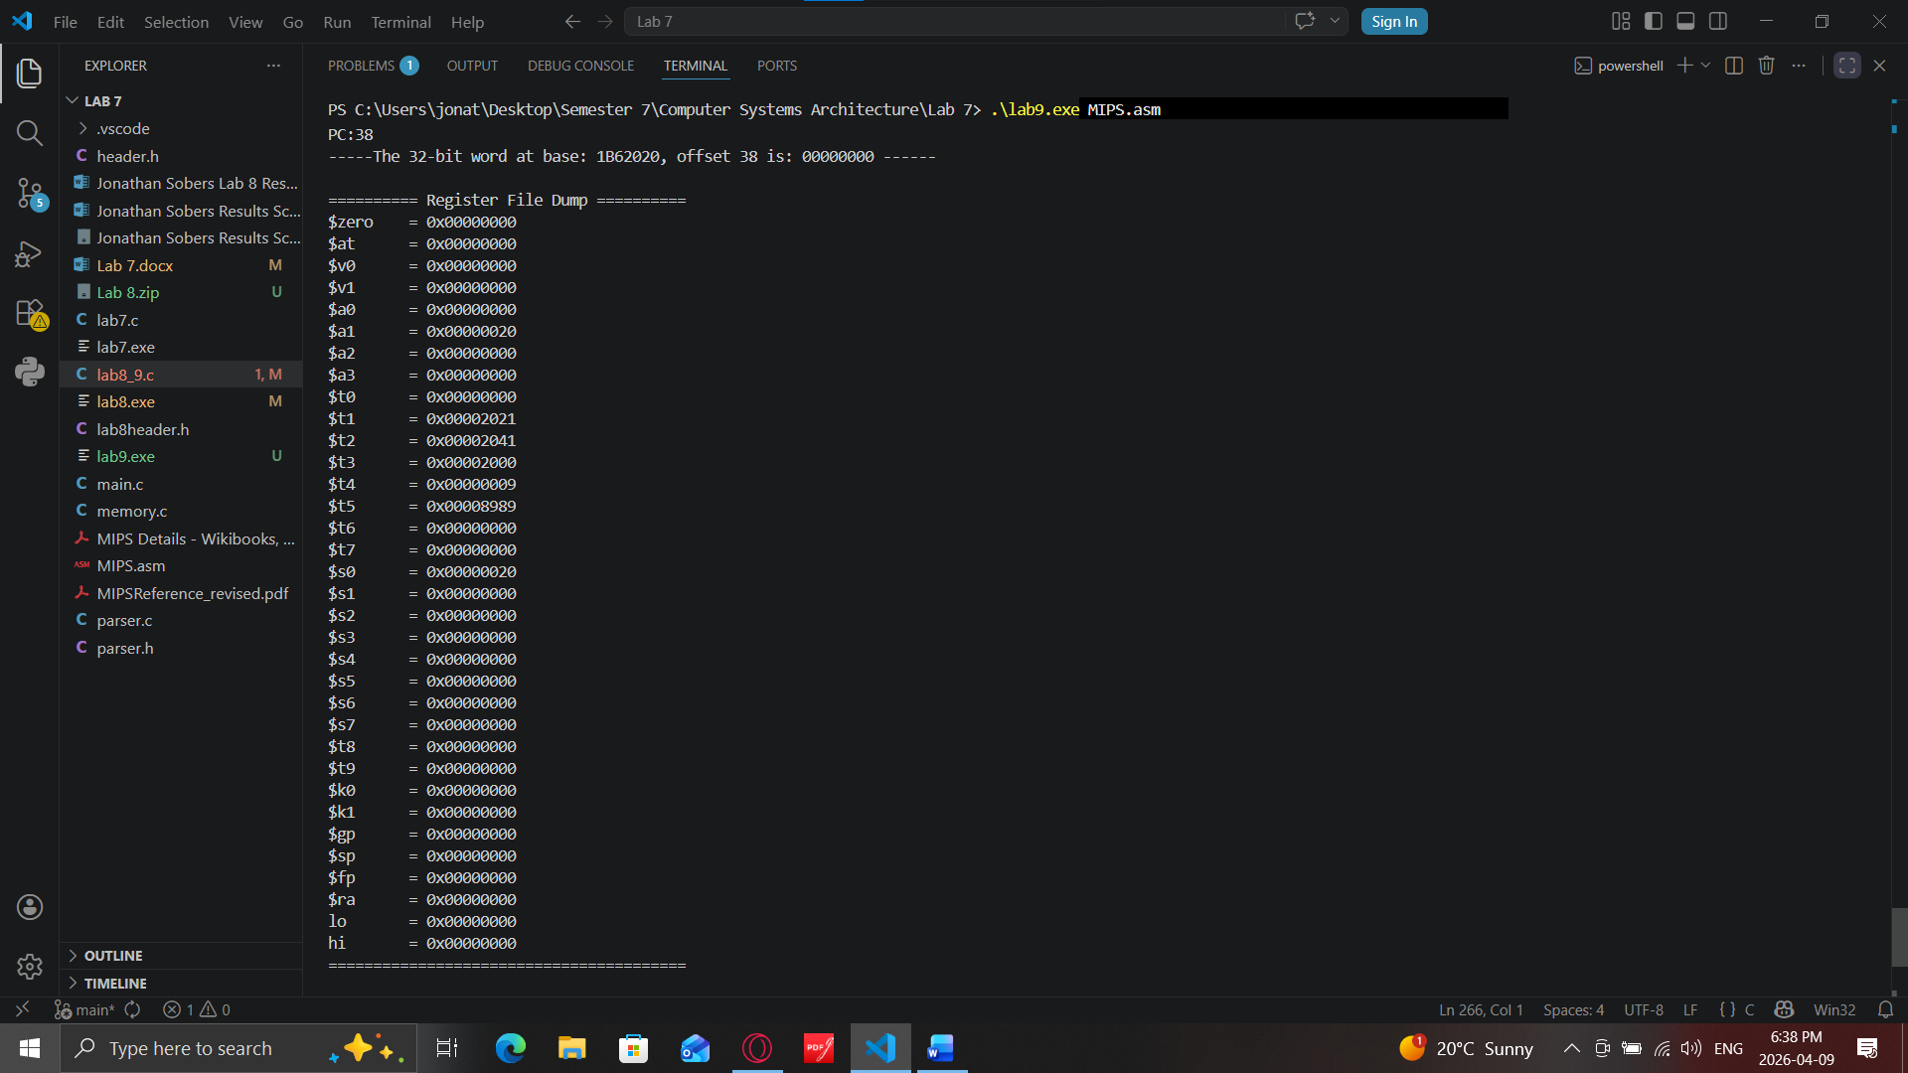
Last Screenshot showing last memory dump at 0x2000
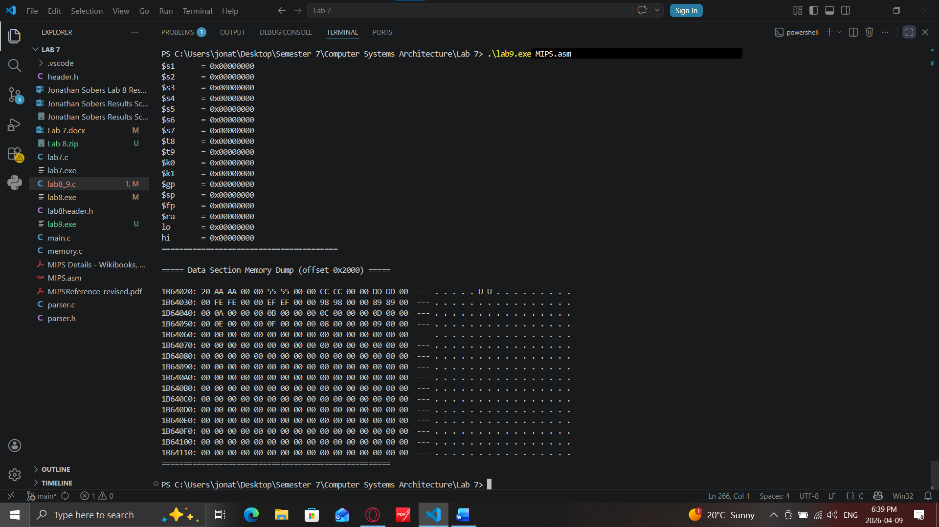
Written question: Please briefly describe the function of the code MIPS.asm.
Answer: The MIPS.asm program swaps the contents of two arrays, testdata1 and testdata2, stored in the data section of memory. It begins by loading the starting addresses of both arrays and a counter variable (value 32) into registers. It then enters a loop that runs 8 times on each iteration then it loads one 4-byte word from testdata1 and one from testdata2, then stores them back in reverse order, which swapped them. After each swap the pointers to both arrays are advanced by 4 bytes to move to the next word, and the loop counter is incremented by 4. The loop continues until the counter reaches 32 (8 words × 4 bytes = 32 bytes), at which point the branch instruction exits the loop, and the program terminates via syscall(systemcall). The result is that all 8 words originally in testdata1 are now in testdata2 and vice versa.

